**AUGMENTED REALITY : NOTES BY SAHIL  
  
Introduction to Extended Reality (Extension of the current reality)**

Subdomain Domains of Extended Reality  
  
*1.AR  
2.VR*

*3.Mixed Reality*

1. **Augmented Reality (AR)** : - SIMPLE WORDS : **Picking the digital objects and putting it into our real world**. Augmented reality means to augment or place digital things in real world.  
     
   FOR DEFINITION: Augmented Reality is an interactive experience of a real-world environment where the objects that reside in the real world are enhanced by computer-generated perceptual information, sometimes across multiple sensory modalities, including visual, auditory, haptic, somatosensory and olfactory. Examples: Pokémon GO, ArLoopa.
2. **Types of Augmented Reality** :   
     
   **1. Marker-based augmented reality** : works on concept of tracking and recognition through marker . Basically we need a marker to augment digital things.  
   **-MARKER** : distinct patterns that cameras can easily recognize and process, and are visually independent of the environment around them .(BASICALLY DOTS ,can be an example) . **Virtual things** can be **attached** to the **shape** of real world entities.

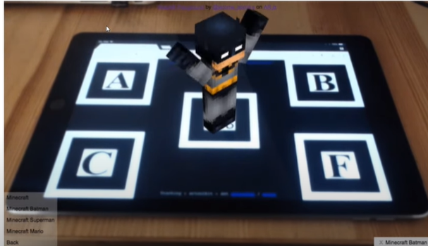

**2. Marker-Less Augmented reality** : This type of AR doesn’t requires any sort of marker . This AR can simply detect your plane and perform the augmentation of your digital objects. Ex : Furniture App (where we can augment furniture to our home environment.)  
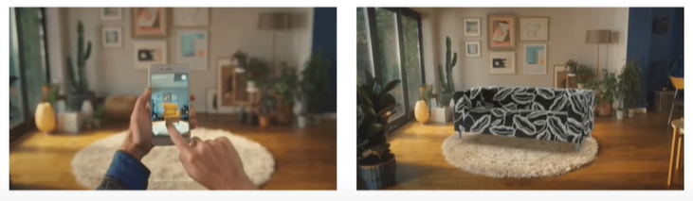

**SLAM (simultaneous localization and mapping)**   
# ALGORITHM USED:   
**Simple words** : using this algorithm , it will scan the environment and find for the plane , on both horizontal and vertical planes and perform the augmentation on that plane.  
**Definition** : Lets you build a map and localize your entities in that map at the same time. SLAM algorithms allow the vehicle to map out unknown environments.

**TYPES OF MARKER-LESS AR :**

* **Super imposition AR:** Simple words , works with object recognition , superimpose some real world objects . Puts n digital object on real object**.**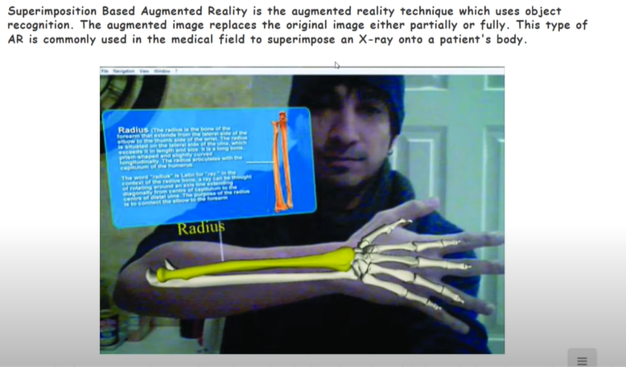
* **Location Based AR :** Helps in locating places , basically , it ties digital content and experience towards a specific place**.** Example , Google Maps but in AR Mode.  
    
  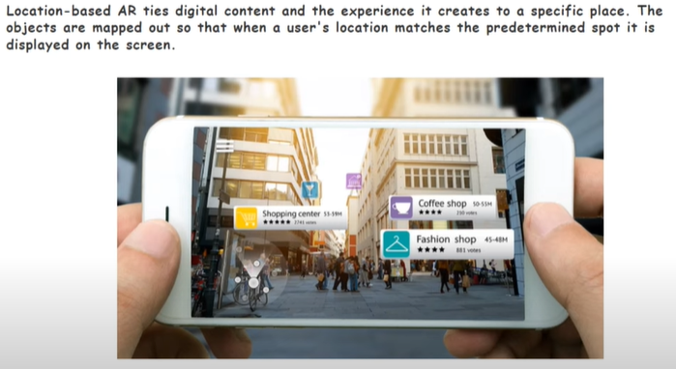
* **Projection Based AR :** Another name for HOLOGRAM.(Still in works)   
  In projection based AR , we actually project things using some device on real world objects .  
  DIFFERENCE BETWEEN **NORMAL AR and Projection Based AR :**

In Normal AR , we actually augment things virtually through our phone to real world , and in Projection based AR , we **project** things virtually to real world. 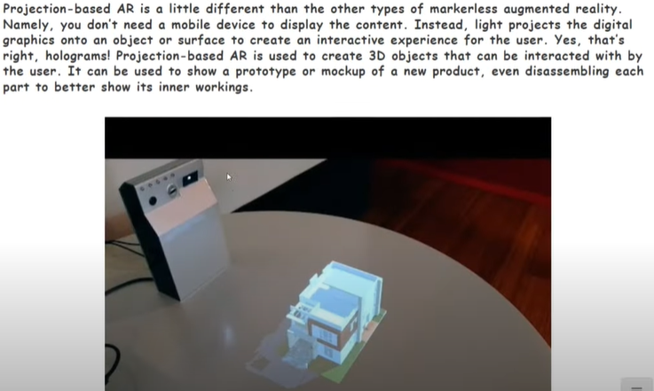

AR Headsets in future will use location based AR, till now Microsoft, JIO, QUALCOMM is launching AR headsets, and it will work on GPS but with AR. HoloLens are also one of the example.

* **Outlining AR :** Mostly used in cars .  
  Simple words ,creating a trailing path with AR .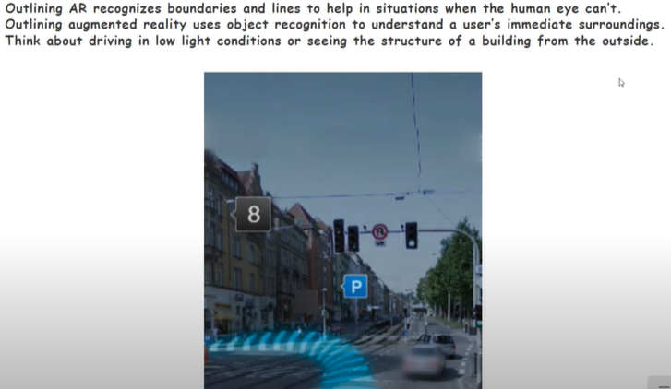

**____________________0x0x0x0x0x0x0x0x0x0 ____________________**

**VIRTUAL REALITY**: Simple words , taking the person itself to the virtual world.  
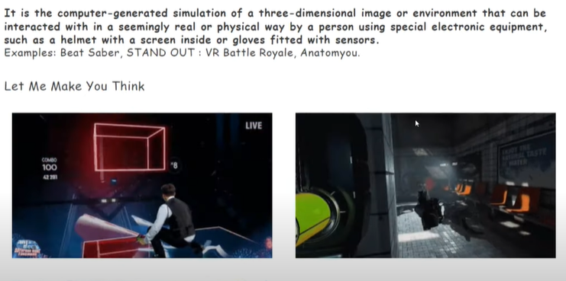

MIXED REALITY : Just like AR , but has more capabilities.   
Mixed is advanced form of AR where we make use Head Mounted Displays (HMS’s) to display the content on the top of real-world sort of blend into the real world.   
Example : AJNA LENS , a startup in INDIA use to make headsets for the military so that they train them.   
